**Project Overview**

The dataset represents financial data for various products sold across different segments and countries. Learners will use this data to answer business questions and generate insights through visualizations.

**1. Import Libraries and Load Data**

#Import liabraries to Google colab

import pandas as pd

import matplotlib.pyplot as plt

import seaborn as sns

print('Libraries are successfully imported')

# Load the dataset

file_xls = 'Financial Sample.xlsx'

data = pd.read_excel(file_xls)

# Display the first few rows to understand the data

print(f'\n List of data\n')

print(data.describe)

**2. Analyse Segment Profitability**

**Question:** Which segment generated the highest total profit?

#Analyse Segment Profitability

#Calculate total profit by segment

profit_by_segment = data.groupby('Segment')['Profit'].sum()

# Plot the result

profit_by_segment.plot(kind='bar', title='Total Profit by Segment')

plt.xlabel('Segment')

plt.ylabel('Total Profit')

plt.show()

**. Segment Profitability Analysis:**

* I have analysed the profitability of various segments and identified which segment generated the highest total profit.
* A bar chart was created to visually represent the total profit by segment, providing an easy-to-understand view of segment performance.

**2. Visualize Sales Trend Over Months**

#Group by month and calculate total sales

monthly_sale = data.groupby('Month Name')['Gross Sales'].sum()

# Sort months correctly

month_order = ['January', 'February', 'March', 'April', 'May', 'June',

               'July', 'August', 'September', 'October', 'November', 'December']

monthly_sales = monthly_sale.reindex(month_order)

#Plot the result

monthly_sales.plot(kind='line', title='Sales Trend Over Months')

plt.xlabel('Month')

plt.ylabel('Total Sales')

plt.show()

**Sales Trend Over Months:**  
The trend of sales was analysed over the months to understand seasonal patterns and variations.  
A line chart was created to display the total sales for each month, ensuring the months are ordered correctly for a clear trend analysis.

**3. Identify Top Performing Country by Units Sold**

**Question:** Which country sold the most units overall?

# Calculate total units sold by country

units_by_country = data.groupby('Country')['Units Sold'].sum()

# Plot the result

units_by_country.plot(kind='bar', title='Units Sold by Country')

plt.xlabel('Country')

plt.ylabel('Units Sold')

plt.show()

**Top Performing Country by Units Sold:**

We examined the total units sold by each country and identified the country with the highest units sold overall.

A bar chart was created to visualize the total units sold for each country, highlighting the best-performing country.

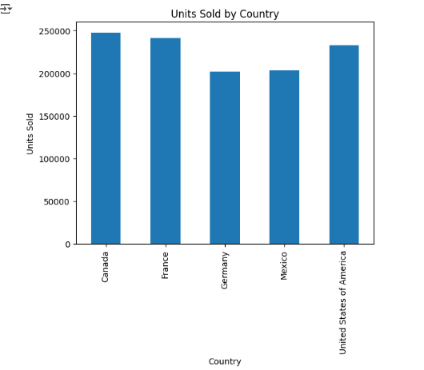

**4. Compare Sales Across Products**

**Question:** How do sales compare across different products?

# Calculate total sales by product

sales_by_product = data.groupby('Product')['Gross Sales'].sum()

# Plot the result

sales_by_product.plot(kind='bar', title='Sales by Product')

plt.xlabel('Product')

plt.ylabel('Total Sales')

plt.show()

**Top Performing Country by Units Sold:**

We examined the total units sold by each country and identified the country with the highest units sold overall.

A bar chart was created to visualize the total units sold for each country, highlighting the best-performing country.



**5. Explore Discount Distribution**

**Question:** What is the distribution of discounts provided?

# Plot the distribution of discounts

plt.hist(data['Discounts'], bins=10, color='skyblue', edgecolor='black')

plt.title('Discount Distribution')

plt.xlabel('Discounts')

plt.ylabel('Frequency')

plt.show()

**Discount Distribution Analysis:**

* We explored the distribution of discounts provided across different sales transactions.
* A histogram was created to show the frequency of discounts, helping to identify how often discounts were applied and their distribution.

**Suggestion for Global Sales:**Based on the analysis, one key suggestion for global sales would be to **focus on expanding sales in the top-performing country** that was identified in the analysis